Adopting Technologies in Drilling & Blasting Operations to Improve Efficiencies

Professor Sushil Bhandari,
Managing Director, Earth Resource Technology, Jodhpur &
Continuous Excellence, Jodhpur and Melbourne

1. Introduction

Mining operations require numerous steps and multiple operations, which are affected by precedent activities and also affect subsequent operations. Blasting is an important step in most mining operations and can impact the efficiency of entire downstream mining operation. Many new technologies, useful to mining and quarrying have recently become available. Some are applicable to drilling and blasting operations. There is potential to apply these technological applications in every aspect of blasting planning, design, and execution - drilling, charging, predicting results and assessing outcomes. Others apply to subsequent mining unit operations and can generate data for objective assessment of blasting results.

The application of information technology is happening at every phase of the mining value chain, from exploration and geological modeling to equipment, operations and maintenance, and logistics and transportation. These new technologies can accurately capture the information component of blasthole drilling, and indeed of each unit operation. Knowledge can be extracted from this information and passed forward and back through the mining system to improve operations and factually assess results. This leads to an evolving and improving system.

There are potentials to take technology advancements like information mobility, advanced data analytics, web solutions for all aspects of blasting operations. Lastly, with the convergence of consumerization and industrialization, the application of “consumer” technologies on hand held units iPhones and Android devices, such as cameras, motion sensors, and positioning in an industrial context, allow field data to be captured and automatically down loaded when the unit is docked, eliminating human error during data transfer.

The ability to use information generated during drilling and blasting operations, and to provide feedback loops for factual assessment is important to obtain drilling and blasting results that best meet the needs of the operation.

In this paper, a number of technologies that can favorably impact drilling and blasting are presented. These advances can provide a way to unify drilling, blast design and blasting implementation. Other technologies are discussed that provide ways to quantitatively assess blasting results throughout the mining system.
Available New Technology

Today, technology has turned drilling and blasting what was once an art into a science. These can provide feedback loops to drilling and blasting. The possibility of setting quantitative fragmentation goals for the operation by being able to objectively measure results at various points in the mining cycle is presented.

Basic considerations such as choice of explosives, maintaining intended hole spacing in drill patterns, and selection of correct delay timing are good starting points for blast-improvement efforts. Another economical approach is to employ one or more of the many blast design and analysis software packages currently available, including those that allow pre-blast bench face profiling and post-blast analysis of fragment size distribution. Most are frequently updated to accommodate new technology and data-collection capabilities. It is worthwhile to look at some technologies which are being adopted in mining industry to make blasting operations efficient and reduce environmental impact.
Drilling & Blasting can use the cutting edge technology. For example with the combination of a laser range finder and Face Profiler, a single operator can accurately measure and record critical depth vs. burden data from a single location, can improve efficiency, maximize job safety and better control of blast design. It is crucial to combine all parameters – inclusive of selection of explosives, rock properties and surface blast design – to devise efficient and cost effective blasting that achieves desired degrees of fragmentation.
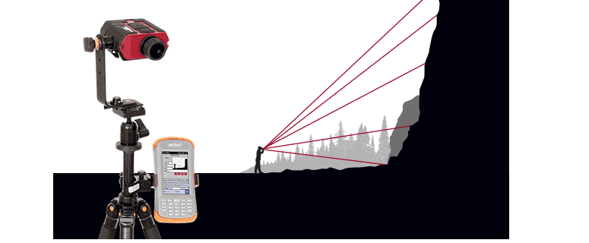
Figure 1 Profiling and designing blasting operations at the face
Blast Explosives Loading Operations: Developing a practical approach to selecting explosives includes: Evaluating the rock characteristics and suitable explosives based on required characteristics; as best as the available data allows; identifying explosive characteristics required to break that rock to give optimum fragmentation; choosing the most suitable bulk explosive pumped or packaged product into the boreholes, and provide the blaster with powerful precision tools to control charging operations. Increasingly sophisticated technology is becoming available for use with bulk trucks. Of particular importance are on board computers bi-directional radio communication and use of GPS systems. These are essential for automated linking of drilling, blast design, blast result predictor software and loading operations. A remote operated blast hole charging or a bulk loading truck with on-board computers bidirectional communication and use of GPS systems are available. A truck with GPS knows the coordinates of the blastholes to be loaded. This can be used to access data from the drill. On-board computing system can then make calculations and truck can proceed to accurately load the holes for the given conditions.
On board system will also record how each hole was loaded. Several mines have now been using this for difficult areas by remotely loading blastholes (Dolting, 2015)
Computer-aided blast design and test-blast practices have replaced trial-and-error, providing a controlled environment. Of course, any blast design is only as good as the data. For the most reliable data, the designers need a couple of high-tech tools. Ideally, the blast will be designed with computer assistance using information from laser surveys, geotechnical and other data. The hole locations are placed on blast plan maps. The final design is downloaded to the drill equipped with GPS capability. The drill machine can then drill the blastholes accurately on the designed locations.
Boretrak System: A stainless steel probe containing gravity sensors and attached to carbon fiber rods is lowered into the hole. Data, regarding pitch, roll and depth of hole is fed into the laptop and produces a three-dimensional view of the actual hole, taking guesswork out of the process. And when a free face is in question relative to bore hole wander, laser profiling is interfaced.

Laser Profiling: Laser profiler provides a three dimensional read of blast face to decide where to drill and load explosives. The laser systems can also be used to survey the muckpile after blasting. The volume of rock broken by shot can be obtained. The swell of the blasted material can be determined. Swell is a measure of the looseness and therefore, diggability of the blast. Swell can be correlated to excavator productivity and this information can be fed back to blast design for use in designing subsequent blasts in the same area. Proper placement and loading of the front row holes is absolutely essential to good blasting. The laser profiler helps the blasting group to design effective front row blasthole locations, or to design explosives loading requirements that reflect actual conditions.

Global Positioning System: Another technology that has great importance for drilling accuracy, and the integration of drilling and blasting operations is GPS applied to drill positioning on individual blastholes. These systems allow the blast plan with hole locations to be downloaded to the drill. Some form of moving display is used to guide the drill onto the designed hole location. The drill can be positioned to within about one third meter of the designed location.

Some systems provide for azimuth as well as coordinates in order that the drill can be accurately located on angled holes. If the elevation coordinate is provided for, hole depths can be adjusted for variations in bench topography.

Therefore, the drill can be accurately spotted without the need for extensive field surveying. Equally important, the systems records exactly where the hole is drilled. This is essential for data transfer to blasthole loading operations, because it provides the way to access hole depth and rock strength profile information in the monitoring database.
Integrated Technology is now available, for new process of blast design that includes getting profile of the face using 2D laser technology hardware and software simplifying the blast designing/face profiling which produces bench height as well as depth and burden data right in the field with ability to make adjustment on PC and export PDF reports. With combination of laser face profiler, a single operator can accurately measure and record crucial depth v/s burden. The system for blast design/rock face profiling , can produce bench height as well as depth and burden data right in the field with the ability to make adjustments on your PC and export PDF reports.
Assessment of Blasting Results: Until recently, the assessment of blasting results has been subjective and thus neither accurate and nor are not impartial. To properly assess the results achieved, quantitative data can now be obtained at the face. Several mines are using computer based fragmentation analysis. The technique can be used for assessing blasted material, dumper, and crusher station. There are techniques to available to predict fragmentation from a particular blast design. Methods like Kuz-Ram, in software form to predict fragmentation size distribution. This can be used for optimizing explosives, patterns or other design changes.

MineExcellence an Innovative Tool

MineExcellence is a suit of innovative mining technology tools. MineExcellence provides some unique technology tools for the mining industry. It marries the latest in technology innovation with years of mining industry experience.

MineExcellence provides the following technology tools:
- Blasting Software: Mine Excellence provides technology tool for blast design, blast data collection and various predictors. The predictors improve operational efficiency and reduce risk in mining operations.
- SBlasting App and Mine Safety App: A skilled Blasting App is used to collect information at mine site and also allows prediction of mine safety mobile app (Android, iPhone and Windows).
- Learning Management System for Mining Companies: Companies can use this to create training courses suitable to their employees or we can create this for them on their behalf. Ebooks, Manuals, Video based training courses from leading mining experts available.
- Social Collaboration Platform for Mining Companies: One can have own profile within company, interact with each other, write blogs.
Being a cloud hosted SaaS solution, one does not require any infrastructure or setup. One just registers and starts using the solution straightaway – Thus there are no additional costs and there is ease of use.

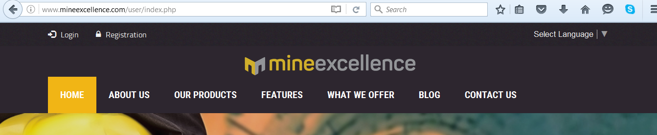

Fig. 2 Mine Excellence a cloud hosted solution for blasting software, learning, mining App
BLASTING SOFTWARE:

Blasting software comprises of multiple modules. Several software are available in both web and desktop versions. Details of blasting related software which cover the blasting lifecycle including blast design, blast execution details, predictors and subsequent analysis are available in Bhandari, 2015.

These are Cloud Hosted Software, namely:

- BLAST INFORMATION MANAGEMENT SYSTEM
- BLAST DESIGNER (BLADES)
- PATTERN SIMULATION & ANALYSIS
- FLYROCK ESTIMATION
- FRAGMENTATION PREDICTOR
- AIR BLAST PREDICTOR
- GROUND BLAST PREDICTOR
- SIGNATURE WAVE ANALYSIS

Blasting software provide some unique characteristics including

- Complete solutions for all aspects of Blasting-Blast design, Blast data collection.
- Predictors for various aspects of mining operations.
- Cloud hosted SaaS capability,
- Mobility solution for Android and iPhone/iPad
- Advanced data analytics.

Learning Management System including video tutorials
- Learning Management Solution is a software application for the administration, documentation, tracking, reporting and delivery of electronic educational technology training programs related to mining and services. LMSs can be used to deliver online courses. One can also create training courses and employees take tests or do self learning on mining aspects. It has features like ability to email course attendees \ availability of key functionality such as slideshows, quizzes, assessments, tasks, video, podcasts, article, calculators, diary. It is possible to add images, audios, videos, pdfs, ppt etc in a course. User can also have live chat with the administrator. Administrator can get the report of all the user and courses. Questionnaire can also be created just like a test for the users. User can download course material and also give their feedback on individual courses.
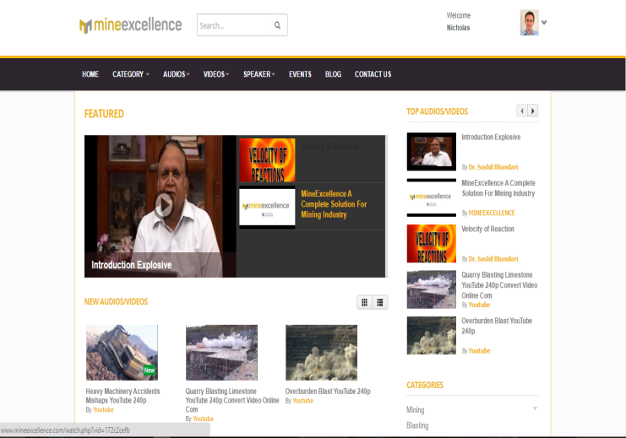
Figure 3 Learning Management System (Video Tutorials)

Mining Specific Messaging / Social Collaboration Platform
Mining collaboration and social platform provide all the information about the mine, its processes, tools and services where anyone can see the information, can like, share the information can follow each other as other social platform.
Features:
- Logged in users can follow, share and interact with each other
- A “suggested users” list for each person after registration. This list is based on location and a few other factors like team name etc. to offer relevancy and encourage interaction.
- Each user has an 'activity stream' on their profile similar to face book - Information which matters to them: their comments, followers and how their content is rated will appear in their stream.
- Just like on Facebook, any item can be 'liked', notifying the people involved. Users can also express themselves by posting status updates which are in turn broadcasted on their followers' activity stream.

SBLASTING APP
To use this application, mining personnel can take the device to blasting site in android or iOS device to the blasting site. All parameters related to drilled holes and explosive charging, stemming etc can be collected. At this stage blaster can recheck predicted fragment size distribution, flyrock distance, ground and air vibration, fragment size etc and if there is variation from designed and/or limits are exceeded then changes in charging, stemming, initiation devices and timing can be done before executing the blast.

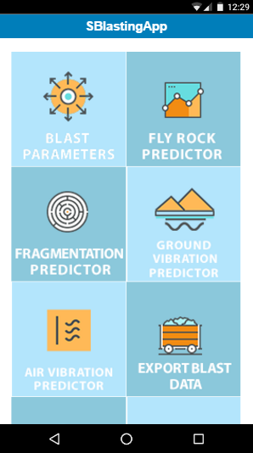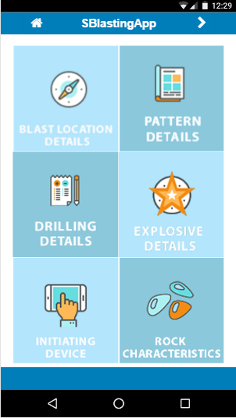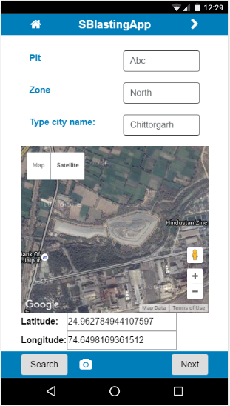
Figure 4 Sblasting App

MINE SAFETY APP
Safety is a very important aspect of blasting. We are providing you with a unique MineSafety APP and Web Platform. This will have features as required by mining companies. This is available on iPhone, iPad, Windows and Android Mobile Phones.
We also have a web based version of this software and the web based version is integrated with Mobile APP via integration.
The use of mobile devices makes it easier to collect data on-site and it is main stream in many places where a mobile workforce is present.

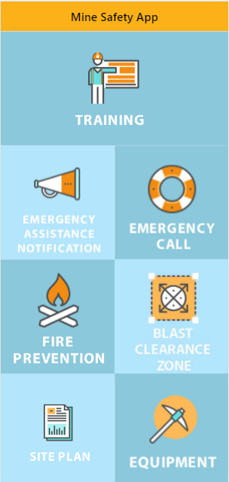
Figure 5.1 Mine Safety App (Menu)
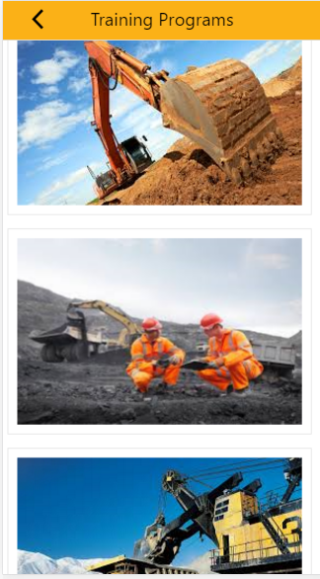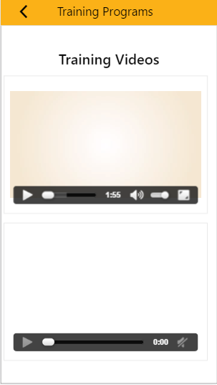
Figure 5.2 Mine Safety App (Training)

Mobile-Learning to Train Employees
With the rise of smart phones, ipads, notebooks and beautifully designed digital watches, technology is quickly replacing textbooks as the medium to obtain and decipher information. Interestingly enough, mobile learning has infiltrated many contracting firms involved in mining and construction, as a new way to approach training for workers.
Mobile learning is becoming an increasingly popular forum for learning and obtaining information. Format and layout of mobile devices enhances learning. Mobile training allows for “some creative and innovativetechniques” to be utilized that can “address the need for helping employees learn” a particular set of skills that may “otherwise be hard to teach.” convenience. Therefore, conducting training on mobile platforms allows the worker to be flexible with their training and take it whenever, and wherever, they want.

The Benefits of Mobile Learning
Although many benefits in terms of access to learning by those in remote regions, and contextualization through GPS tracking systems- mobile learning offer workers so much more, more notably information that is digestible and a device that is flexible.
Digestible Information
The first advantage to consider is that mobile learning offers a way to provide workers with information that is both digestible and understandable. Meaning that all of your training will be easy to read and navigational, for even the amateur technology users. There won’t be a need to provide reams of paper and long presentations, all of this can be incorporated into the mobile platform. Furthermore, these platforms give you an opportunity to provide maps and directions, showcase in-depth health and safety videos, offer podcasts and ebooks, and provide sufficient training. Workers may even have a number of language options.
Breaks Down Language Barriers
One of the marvels of mobile devices is that they are very much multilingual, regardless of the geographical location of your worker. Mobile learning gives the opportunity to offer training in a multitude of languages, and make that customizable to each region. allowing for a multitude of languages, across any region, which ensures no matter where your contract worker resides, they can receive adequate orientation training.
It’s Portable, Take Training Anytime, Anywhere!
Mobile devices are transportable and easy to store away inside worker’s pocket. This means that in terms of training, worker can take it anywhere and anytime. It could be 4 am, or 9 pm, once they have access to a mobile phone and a sufficient internet connection, they will be able to undertake training. Furthermore, by using mobile learning, the control of training is into the hands of the worker.

Flexibility
Mobile learning also offers workers one great perk-flexibility. Mobile learning ensures training process is conducted in a speedy and convenient fashion in spite of sitting in a classroom for hours. Workers can simply log in and start their training.
Fully customizable for mobile platforms, in fact, a number of our users in the past have used that option, which is generally quicker than the desktop alternative. It is an online orientation platform that allows workers to register, upload documents and photos, and undertake their training. This process can even be adapted to suit the type of worker and the location of mine site or plant.
Verifying the identity of worker
Of course, verifying the identity of worker can be an issue when they’re completing a task online. Technically, anyone could take the training and pretend to be organization worker,. However, pretending to be someone else is impossible thanks to a new feature called Identity Capture. This new feature allows you to verify that the identity of the user matches that of employee. The feature works by taking a series of photographs of the worker while they take their course and verifying identity that the person who arrives on site matches the person who took the course!

CONCLUSIONS
Adapting to change is never easy, but by choosing the technology as well as a plan for adaptation and training have helped many operations to successfully overcome challenges and they have ended up with a hugely successful, more consistent and much safer process for blasting operations. On the site data collection, use of predictors and alter the charging, timing and sequence of initiation can improve outcome. The system for blast design / rock face profiling is face profiler system, which produces bench height as well as depth and burden data right in the field with the ability to make adjustments on PC and export PDF reports. With the combination of the laser rangefinder and Face Profiler, a single operator cans accurately measure and record critical depth vs. burden data from a single location Information gathering of blasting results and feeding the information to designers is an important tool. New methods of delivery of skill development programmes using webcasting, web or mobile application may be used (e-learning, m-learning). When actual fragmentation is measured continuously, the results can be used to determine whether the blasting program is meeting stated goals. An operation using modern technology can develop fragmentation goals that best benefit the entire mining system. Once these goals are being me, or whether the trend is away from these goals. When the trend is away from stated goals, one can correlate back to bulk truck and drill data. Once the problem is corrected, fragmentation can be monitored to insure that it is trending back to the desired distribution.
References
Bhandari, S, 2011, Information Management for Improved Blasting Operations and
Environmental Control, 3rd Asia- Pacific Symposium on Blasting Techniques , August 10-13, Xiamen, China
Bhandari, S., Parihar, C.P., Garg, R, Bhandari, A.; Integrated Solutions for Optimized and
Environmentally Controlled Blasts, 11th International Symposium on Rock Fragmentation by Blasting, Sydney, August, 2015
Bhandari, S, 2015, New Technologies for Optimisation & Environmental Controls Of Blasting Results,
Journal of Mines Metals and Fuels, Explosive Conclave 2015
Rodgers, J. A., 1999 Measurement Technology in Mining, Proceeding MINEBLAST 99, Duluth, Minnesota, pp 17-23.
Parihar, C. P., Bhandari, S., Improving Blasting Operations Using Data Management and Analysis, 10th
International Symposium on Rock Fragmentation by Blasting, New Delhi, August, 2012
La Rosa, D.; 2001 The Development of an Information Management System for the Improvement of Drilling and Blasting
in Mining Operations. Proc. 29th Int. Symp.Computer Applications in the Minerals Industries. Beijing,367-372,

http://www.lasertech.com/Blast-Design-Rock-Face-Profiling.aspx

Dolting, S., Using new technology to improve drilling and blasting at Savage River Mine, Drill Blast 2016http://www.miningiq.com/mining/white-papers/using-new-technology-to-improve-drilling-and-blast

Dolting S., The Practical use of Technology in a Challenging Mining Application, Drill Blast
2016 http://www.drillandblastevent.com.au/media/1002752/57029.pdf

